# Overview blocks for Excel

## **Reuse of Word and Powerpoint blocks**

All table and text blocks can be re-used in Excel.

To use any block in Excel, prefix all definitions with RepGen:TEXT or RepGen:TABLE.

The data will be put on the exact location where the definition resides.

## **Limitations**

* + 1. **Text blocks**

Cells referencing a text block will have their content replaced with the actual value received from the REST APIs.

Style and format information will be preserved. Report Generator will try and generate numeric-type values when the data provided by the REST API is numeric; otherwise, the data will be inserted as text.

Formulas referencing “text block” cells will work as expected.

* + 1. **Table blocks**

Report Generator inserts new lines starting from the line that contains the “RepGen:TABLE;BLOCK_NAME;options…” definition. Existing content below the “RepGen:” will not be overwritten.

Report Generator will not apply any style or format to inserted cells. However, Report Generator will try and generate numeric-type values when the data provided by the REST API is numeric; otherwise, the data will be inserted as text.

Formulas referencing cells that are part of the block template will not be updated.

As a result, it is recommended to reserve one worksheet per table block and insert formulas in one or more consolidation worksheets. Formulas referencing template cells should reference whole columns (e.g.: =SUM('raw_data_worksheet'!D:D)), or cell ranges that are large enough to address all data extracted from the REST APIs (e.g.: =SUM('raw_data_worksheet'!D2:D20000)).

* + 1. **Graph blocks**

Graph blocks are not supported in Excel: only table and text blocks.

## **Block IFPUG_FUNCTIONS**

This block will display the Transaction Functions and the Data Functions as listed below. The parameter

* HEADER
  + NO: means there is no header displayed from the data from the REST API
  + YES: means that the header will be taken into account as stored in the REST API
* TYPE
  + TF = Transaction Function display
  + DF = Data function display

Example:

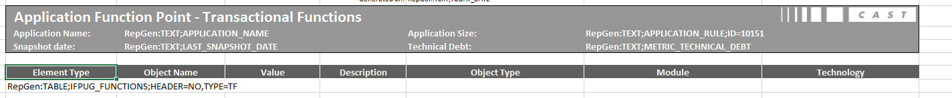

Result:

